SIMATS ENGINEERING (SAVEETHA SCHOOL OF ENGINEERING)
Department of Computer Science and Engineering
CO1 ASSESSMENT TOOL 1 – Case Study Analysis
Course Code: | CSA10 / CSA1003 | Course Title: | Software Engineering
CO Assessed: | CO1 | Assessment: | Assessment Tool 1 – Case Study Analysis
Weightage: | 20% | Total Marks: | 25
CO1 Statement: | Apply advanced methodologies and agile project management techniques to manage software projects effectively
Student Name: | Priyadharshini K S | Reg. No.: | 192511248
Date: |  | Duration: | 60 minutes

Code of Conduct
I _Priyadharshini K S 192511248__ (Name / Reg No) certify that this submission is my original work and that I have adhered to the guidelines specified for this assessment. I understand that any violation of academic integrity rules will result in disciplinary action.
Signature of the Student: _Priyadharshini K S_

Annexure A – Case Study Analysis
Vehicle Service Scheduling and Predictive Maintenance Management System

- Understand the Problem Statement

  - Explain the problem in your own words.
The Vehicle Service Scheduling and Predictive Maintenance Management System solves the problems of manual vehicle service management. Customers often forget service dates due to the absence of reminder notifications. Service records maintained on paper are difficult to manage and retrieve. Manual booking is time-consuming and prone to errors. The proposed system automates service scheduling, maintains digital records, and improves customer satisfaction.
  - Identify the objectives of the proposed system.
  - Automate the vehicle service scheduling process.
  - Maintain digital records of vehicle maintenance history.
  - Send automatic reminders for upcoming vehicle services.
  - Reduce unexpected vehicle breakdowns through timely maintenance.
  - Improve customer convenience with online service booking.
  - Minimize manual paperwork and human errors.
  - Enable easy tracking of service status and maintenance history.
  - Improve the efficiency and productivity of service centre operations.
  - Provide secure storage and management of customer and vehicle data.
  - Enhance overall customer satisfaction by delivering faster and more reliable services..

  - Automate the vehicle service scheduling process.
  - State the scope of the problem.
- Customer registration.
- Vehicle registration.
- Online service booking.
- Service history management.
- Automatic reminder notifications.
- Mechanic assignment.
- Admin management.
- Report generation.
- Secure database management.
- Service status tracking.

- Identify Key Stakeholders and Challenges

  - Identify all the stakeholders involved in the system.
The stakeholders involved in this project are:
    - Vehicle Owners
    - Service Centre Manager
    - Mechanics
    - System Administrator
  - Explain the roles and responsibilities of each stakeholder.
Vehicle Owner:
- Register vehicle details in the system.
- Book service appointments online.
- View vehicle service and maintenance history.
- Receive automatic service reminder notifications.
- Track the status of booked services.
Service Centre Manager:
- Manage customer service bookings.
- Schedule and assign mechanics for servicing.
- Monitor daily service centre operations.
- Update service progress and completion status.
- Generate service and maintenance reports.
Mechanic:
- Inspect and service vehicles.
- Perform repairs and maintenance activities..
- Update maintenance records after servicing.
- Report completed service work to the manager.
- Check previous service history for accurate maintenance.
System Administrator:
- Create and manage user accounts.
- Maintain database security and access control.
- Monitor overall system performance.
- Perform data backup and recovery operations.
- Generate administrative and system reports.

  - Discuss the major challenges and issues faced by the stakeholders.
- Customers forget service dates.
- Manual records are difficult to maintain.
- Data retrieval is time-consuming.
- Human errors occur frequently.
- Paper records may be damaged.
- Appointment booking is slow.
- No automatic reminders.
- Poor communication with customers.
- Difficult report generation.
- Low operational efficiency.
- Analyse the Current Approach

  - Describe the existing system or current process.
The existing vehicle service management system mainly depends on manual processes. Customers visit or contact the service centre to book appointments. Vehicle records are maintained using paper files, making retrieval difficult. There are no automatic reminder notifications for scheduled servicing. Managers manually assign work to mechanics and prepare reports. The system is simple but lacks automation and efficient record management.
  - Identify its strengths and limitations.
Strength:
- Easy to understand.
- Low implementation cost.
- No advanced technical knowledge required.
- Suitable for small service centres.
- Minimal employee training required.
- Easy manual verification.
- No internet dependency.
- Simple workflow.
- Flexible for fewer customers.
- Cost-effective.
Limitation:
- Manual record keeping.
- Difficult data retrieval.
- No automatic reminders.
- Paper records may be lost.
- Human errors are common.
- Slow appointment process.
- No real-time tracking.
- Poor communication.
- Difficult report generation.
- No digital automation.

  - Analyse the problems or gaps that need to be addressed.
The current system has several limitations that reduce efficiency. Manual record keeping makes data management difficult and increases the chances of errors. Customers often miss service schedules because reminder notifications are unavailable. Managers cannot monitor services effectively, and mechanics spend additional time searching previous records. These problems reduce customer satisfaction and highlight the need for an automated software solution.

- Propose a Suitable Solution Using Software Engineering Principles

  - Design a software-based solution for the given problem.
The proposed solution is a web-based Vehicle Service Scheduling and Predictive Maintenance Management System. It allows users to register vehicles, book service appointments, and receive reminder notifications. Managers can assign mechanics and monitor service progress through a centralized dashboard. Digital records improve data management and reduce paperwork. The system enhances efficiency, accuracy, and customer satisfaction.

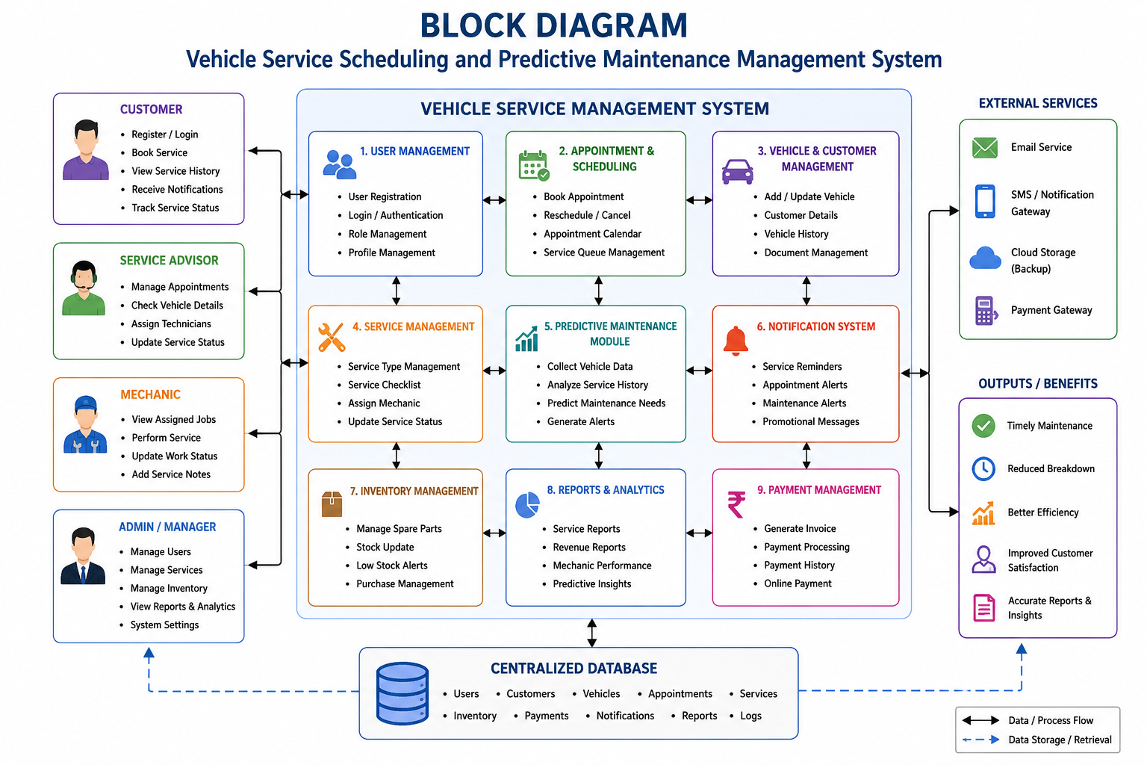

  - Describe the major functional modules of the proposed system.
- User Registration Module
- Vehicle Registration Module
- Service Booking Module
- Maintenance History Module
- Reminder Notification Module
- Admin Dashboard
- Report Generation Module
- User Authentication
- Database Management

  - Identify the functional and non-functional requirements.

Functional Requirements:  • User Registration Module  • Vehicle Registration Module  • Service Booking Module  • Maintenance History Module  • Reminder Notification Module  • Admin Dashboard  • Report Generation Module | Non-Functional Requirements:  • Security  • Reliability  • Scalability  • User-Friendly Interface  • High Performance  • Data Backup and Recovery

  - Explain how software engineering principles such as modularity, scalability, maintainability, reliability, usability, and security are incorporated into your solution.
Modularity:
- The system is divided into independent modules such as User Management, Vehicle Registration, Service Booking, Maintenance History, and Report Generation.
- Each module performs a specific function independently.
- Makes development, testing, and maintenance easier.
Scalability:
- The system can support an increasing number of users and vehicles.
- New features and modules can be added without affecting existing functions.
- Suitable for future expansion to multiple service centres.
Maintainability:
- Bugs and errors can be fixed easily.
- Software updates and feature enhancements can be implemented quickly.
- Modular design simplifies long-term maintenance.
Reliability:
- Ensures accurate storage of customer and vehicle data.
- Provides consistent system performance with minimal errors.
- Regular data backup and recovery improve system reliability.
Usability:
- Provides a simple and user-friendly interface.
- Makes booking services and tracking maintenance easy for customers.
- Reduces training time for employees and administrators.
Security:
- Uses secure user authentication and login.
- Implements role-based access control for different users.
- Protects customer and vehicle data through secure database management and encrypted passwords.

- Justify the Chosen Methodology/Framework

  - Select an appropriate Software Development Life Cycle (SDLC) model or software development framework (e.g., Agile, Scrum, Waterfall, Spiral, DevOps).
The Agile SDLC model is selected because it develops software through small iterations called sprints. Each sprint includes planning, development, testing, and review. Agile allows continuous customer feedback and supports changing requirements. It improves software quality by identifying errors early. Therefore, Agile is the most suitable model for this project.
  - Justify why the selected methodology/framework is suitable for the proposed system.
Agile provides flexibility and continuous improvement during software development. Customer feedback after each sprint helps improve system quality. Frequent testing reduces defects and development risks. The modular approach simplifies future updates and maintenance. Agile also supports adding new features without affecting existing modules.
  - Explain how it supports successful project development and maintenance.
Agile divides the project into smaller development cycles, making the project easier to manage. Continuous testing improves software reliability and performance. Developers can fix errors quickly and implement customer suggestions immediately. Future maintenance becomes easier because modules are developed independently. This approach ensures successful project completion and long-term software maintenance.

- Discuss Expected Outcomes and Limitations

  - Describe the expected benefits of the proposed solution.
- Automatic service reminders.
- Online appointment booking.
- Digital maintenance records.
- Reduced paperwork.
- Improved service efficiency.
- Better customer satisfaction.
- Accurate report generation.
- Easy service tracking.
- Reduced human errors.
- Secure data management.
  - Explain how the solution addresses the identified challenges.
- Automates scheduling.
- Sends reminder notifications.
- Stores digital records.
- Improves communication.
- Reduces paperwork.
- Enables online booking.
- Improves report generation.
- Tracks maintenance history.
- Reduces errors.
- Enhances service quality.
  - Discuss potential risks, implementation challenges, and limitations.
Potential Risks:
    - Data security and privacy breaches may expose customer information.
    - Server failures or system crashes can interrupt service availability.
    - Data loss may occur if proper backup mechanisms are not implemented.
    - Cyberattacks such as hacking or malware can affect system security.
    - Incorrect data entry may lead to inaccurate service records.
Implementation Challenges:
    - High initial development and deployment cost.
    - Training is required for employees to use the new system effectively.
    - Migrating existing manual records to the digital database can be time-consuming.
    - Reliable internet connectivity is necessary for smooth system operation.
    - Regular software updates and maintenance are needed to ensure performance.
Limitations:
    - The system depends on a stable internet connection.
    - Hardware or server failures can affect system availability.
    - Small service centres may find implementation expensive.
    - Regular maintenance is required to keep the software secure and updated.
    - Some users may face difficulty adapting to the new digital system.

  - Suggest possible future enhancements.

AI-Based Maintenance Prediction – Predict potential vehicle issues before breakdowns using Artificial Intelligence.
Mobile Application – Develop an Android/iOS app for booking services and receiving reminders.
Online Payment Integration – Enable secure online payments for vehicle service charges.
GPS Integration – Help users locate the nearest authorized service centres.
Cloud Storage – Store service records securely on the cloud for easy access and backup.
SMS & Email Notifications – Send service reminders and status updates through SMS and email.
IoT-Based Vehicle Monitoring – Integrate sensors to monitor vehicle health in real time.
Chatbot Support – Provide 24/7 customer assistance for booking and enquiry services.

Rubrics for Calculation
Criteria | Excellent (5 Marks) | Good (3 Marks) | Satisfactory (2 Marks) | Needs Improvement (1 Mark)
Problem Understanding | Clearly explains the problem, objectives, and scope with complete understanding. | Explains the problem with minor omissions. | Basic understanding with limited explanation. | Poor understanding; objectives and scope are unclear or missing.
Stakeholder & Challenge Analysis | Identifies all stakeholders, their roles, and challenges with clear analysis. | Identifies most stakeholders and challenges with adequate analysis. | Identifies only a few stakeholders or challenges. | Stakeholders and system analysis are incomplete or inaccurate.
Current System Analysis | Thoroughly analyzes the existing system, strengths, weaknesses, and identifies all gaps. | Good analysis with most strengths and weaknesses identified. | Limited analysis with partial identification of issues. | Proposed solution is unclear or inappropriate; requirements are largely missing.
Proposed Software Solution & Software Engineering Principles | Proposes an innovative, feasible solution applying appropriate software engineering principles (modularity, scalability, maintainability, security, etc.). | Suitable solution with good application of software engineering principles. | Basic solution with limited application of software engineering principles. | Methodology is inappropriate, poorly justified, or not discussed.
Methodology/ Framework Justification | Selects the most suitable SDLC/model/framework and provides strong technical justification. | Suitable methodology selected with adequate justification. | Methodology selected but justification is weak. | Outcomes, limitations, or future enhancements are missing; report lacks organization and clarity.

Criteria | Mark
Problem Understanding | /5
Stakeholder & Challenge Analysis | /5
Current System Analysis | /5
Proposed Software Solution & Software Engineering Principles | /5
Methodology/ Framework Justification | /5
TOTAL | /5

